HealthConnect Security Requirements Document (CIA Triad)
Work by: Renis Hila

Table of Contents
Confidentiality 3
Known Limitations 4
Integrity 5
Known Limitations 6
Availability 7
Known Limitations 8
Summary 9
What I Implemented 9
Production Readiness 9
What I Learned 9
Final Thoughts 10

Confidentiality
Confidentiality ensures that information is accessible only to those authorized to have access. For a health-related application, this is the highest priority due to the handling of Protected Health Information (PHI) and Personally Identifiable Information (PII).
Requirement | Description | Implementation | Status
JWT Authentication | All API requests must be authenticated using JWT tokens with 2-hour expiration. | Implemented JWT tokens in auth-service with 2-hour expiration. Tokens validated by API Gateway before forwarding requests. | ✅ Implemented
Role-Based Access Control (RBAC) | Access to application features must be limited based on user role (patient, doctor, admin). | Implemented RBAC with three roles: patient, doctor, admin. Each service validates user role from JWT before processing requests. | ✅ Implemented
Database Isolation | Each microservice must have its own isolated database to prevent unauthorized cross-service data access. | Implemented database-per-service pattern. Each of the 7 services has its own PostgreSQL database instance. | ✅ Implemented
Network Security | Internal microservice communication must be restricted to prevent external access. | All services run in Docker network. Only API Gateway exposed externally. Service-to-service communication via internal network. | ✅ Implemented
Doctor-Patient Access Control | Doctors can only access data of patients assigned to them. | Implemented doctor-patient mapping table. All patient data queries filtered by assigned doctor relationship. | ✅ Implemented
GitHub Secrets Management | Deployment credentials must never be exposed in logs or source code. | Docker credentials stored as GitHub Secrets. Access restricted to specific workflows and protected branches only. | ✅ Implemented
Rate Limiting | Prevent brute-force attacks and credential enumeration through rate limiting. | Implemented express-rate-limit across all services. Login limited to 5 attempts per 15 minutes. Other endpoints limited to 100 requests per 15 minutes per IP. Tested and verified working - 6th login attempt blocked correctly. | ✅ Implemented

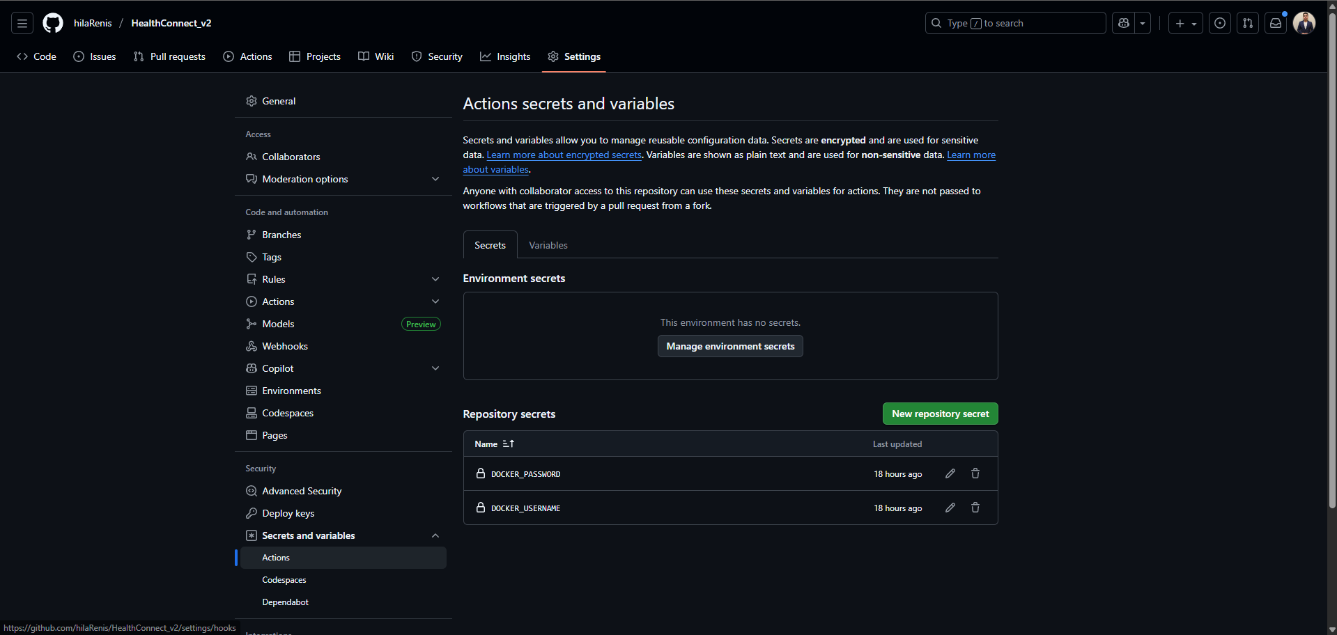

Known Limitations
While the access control and authentication implementation is solid, there are some confidentiality features I didn't implement due to time constraints:
- No HTTPS/TLS: All communication is HTTP. Would need SSL certificates and HTTPS enforcement.
- No database encryption at rest: PostgreSQL databases don't encrypt data on disk. Would need OS-level encryption.

Integrity
Integrity ensures that data is accurate, complete, and reliable, and that systems operate as intended without unauthorized modification.
Requirement | Description | Implementation | Status
Data Validation | All user inputs must be validated before processing to prevent corruption or injection attacks. | Implemented validation in all services. Check required fields, email format, date formats, and business rules before database operations. | ✅ Implemented
Database Constraints | Database must enforce data integrity rules at storage level. | Implemented PRIMARY KEY, FOREIGN KEY constraints. Email uniqueness constraints. NOT NULL constraints on required fields. | ✅ Implemented
Audit Logging | All significant data changes must be logged with who performed the action and when. | Implemented Kafka event sourcing. All create/update/delete operations publish events (USER_CREATED, APPOINTMENT_UPDATED, etc.) for audit trail. | ✅ Implemented
Soft Delete Pattern | Data must be preserved even when 'deleted' to maintain audit trail and comply with healthcare regulations. | Implemented soft delete with deleted_at timestamps across all tables. Data never permanently removed, only marked inactive. | ✅ Implemented
Secure Deployment | Code deployment process must guarantee only authorized code is deployed. | Implemented CI/CD pipeline with GitHub Actions. Code reviews required, branch protection enforced, Docker images signed with SHA. | ✅ Implemented
Error Handling | System must handle errors gracefully without exposing sensitive information. | Implemented try-catch blocks in all services. Generic error messages to clients. Detailed errors logged internally only. | ✅ Implemented
Input Sanitization & Security Headers | Prevent XSS and injection attacks by sanitizing all user input and enforcing security policies. | Implemented xss-clean middleware across all 7 services to sanitize user input. Added Helmet middleware for security headers (Content-Security-Policy, X-Frame-Options, X-Content-Type-Options, Strict-Transport-Security, etc.). Defense in depth approach with 8 security headers protecting against XSS, clickjacking, MIME-sniffing attacks. Tested and verified working. | ✅ Implemented

Known Limitations
The data validation and audit trail implementation is solid, but there are some areas I didn't cover:
- No validation library: Currently using manual validation. Production apps use libraries like Joi or Yup for better validation.
- No checksums: File uploads don't verify integrity with checksums. Would need hash verification for uploaded files.
- xss-clean deprecated: The npm package shows a deprecation warning. Still functional but should consider alternatives like dompurify in future.

Availability
Availability ensures that authorized users can access the system and information when needed, without unreasonable delays or interruptions.
Requirement | Description | Implementation | Status
Health Checks | System must provide health check endpoints to monitor service status. | Implemented /health endpoint in all 7 services. Returns service name and status. Used by Prometheus for monitoring. | ✅ Implemented
Monitoring & Alerting | Automated systems must monitor health and performance of all components. | Implemented Prometheus + Grafana monitoring. 5 specialized dashboards. 16 alert rules covering service down, high error rate, slow response, high resource usage. | ✅ Implemented
Graceful Error Handling | System must handle errors without crashing and provide useful feedback. | Implemented try-catch error handling in all services. Services return proper HTTP status codes (400, 401, 403, 404, 500) with error messages. | ✅ Implemented
Data Persistence | Data must be preserved during service restarts or failures. | Implemented PostgreSQL for persistent storage. Docker volumes ensure data survives container restarts. Soft delete prevents accidental data loss. | ✅ Implemented
Dependency Management | Application must handle external service failures gracefully. | Services check database connectivity on startup. Kafka connection failures logged but don't crash services. Service isolation prevents cascade failures. | ✅ Implemented
Scalable Architecture | System must be designed to scale horizontally as load increases. | Implemented microservices architecture with Docker. Each service can scale independently. Database-per-service pattern prevents bottlenecks. | ✅ Implemented

Known Limitations
The monitoring system is solid, but there are some availability features I didn't implement:
- Single point of failure: API Gateway is single point of failure. Would need load balancer with multiple gateway instances.
- No circuit breakers: Services don't have circuit breakers for failing dependencies. Would use libraries like Opossum or Hystrix.
- No auto-scaling: Containers don't auto-scale based on load. Would need Kubernetes Horizontal Pod Autoscaler.
- No disaster recovery: No backup/restore procedures documented. Would need RTO/RPO defined with backup strategy.

Summary

What I Implemented
This document confirms that the HealthConnect application implements the following CIA Triad security measures:
- Confidentiality: JWT authentication, RBAC, database isolation, network security, GitHub secrets, rate limiting
- Integrity: Input validation, input sanitization (NEW), database constraints, audit logging, soft delete, security headers, secure deployment
- Availability: Health checks, Prometheus monitoring with 16 alerts, graceful error handling, data persistence, scalable microservices architecture

Production Readiness
Is HealthConnect production-ready from a security perspective? Honestly, no — but it's pretty close.
What's working well: Authentication is solid, authorization works correctly, data integrity is maintained, monitoring catches problems, and the rate limiting + input sanitization + security headers protect against common attacks (brute force, XSS, injection, clickjacking).
What would still need to be added for production: HTTPS/TLS for encrypted communication, database encryption at rest, load balancer for high availability, and comprehensive backup/restore procedures.

What I Learned
Implementing these security features taught/reminded me several important lessons:
First, I remembered that security is not a single feature but a series of layers. Each layer (authentication, authorization, validation, sanitization, rate limiting, monitoring) protects against different threats. Removing any one layer weakens the entire system.
Second, rate limiting is surprisingly effective. After implementing it, I tested by trying to brute-force the login endpoint. After 5 failed attempts, the 6th request was immediately blocked with a clear error message. This simple feature prevents so many attack vectors.
Third, I discovered that security headers (from Helmet) are like free protection. Adding helmet() to my Express apps took literally 2 lines of code but enabled 8 different security protections automatically. I learned about Content Security Policy, clickjacking prevention, and MIME-type sniffing attacks - threats I didn't even know existed before this implementation.
Finally, I remembered what my cyber security teacher used to say, a good security means thinking like an attacker. When I implemented input sanitization, I tried to inject XSS scripts into user names and appointment notes. Seeing the sanitizer strip out the malicious code made me see how easily applications can be exploited without proper protection.

Final Thoughts
Security is hard. There's always one more thing you could add, one more attack vector to consider. The goal isn't perfect security, which is impossible to achieve, but reasonable security given the constraints.
For HealthConnect, I prioritized the security measures that:
1) Protect against the most common attacks (authentication, XSS, injection, brute force)
2) Comply with healthcare regulations (GDPR, data retention, audit trails)
3) Can be realistically implemented and tested
The recent addition of rate limiting and input sanitization significantly improved the security posture with minimal effort. This taught me that security doesn't have to be complicated — sometimes the simplest measures (like limiting login attempts) are the most effective.
HealthConnect isn't perfect, but it demonstrates solid understanding of security principles, practical implementation skills, and the ability to identify and fix security gaps. The CIA Triad analysis helped me think systematically about security rather than just adding random features.

